1. Open IP modification software

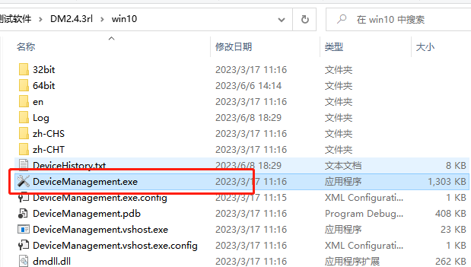

1. Click “Search”

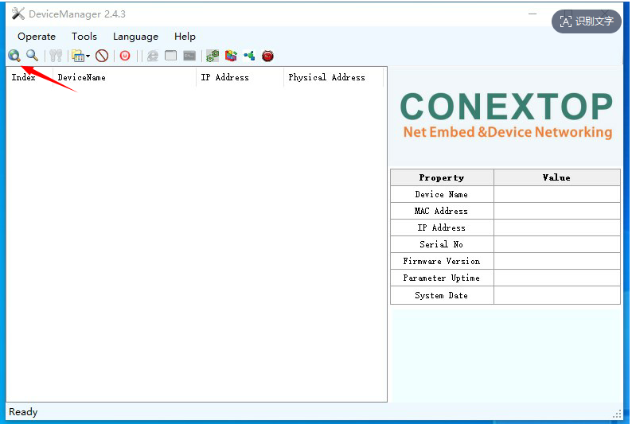

1. Double-click the searched device IP

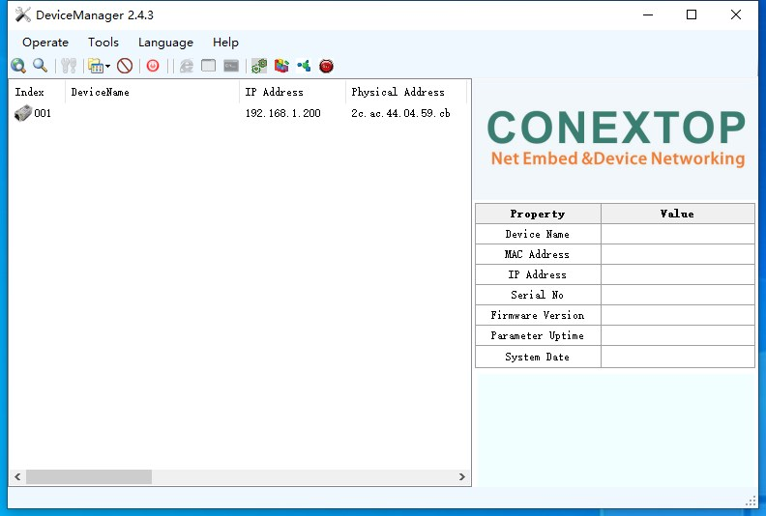

1. Enter the username and password to enter the IP modification interface (username and password are both admin）

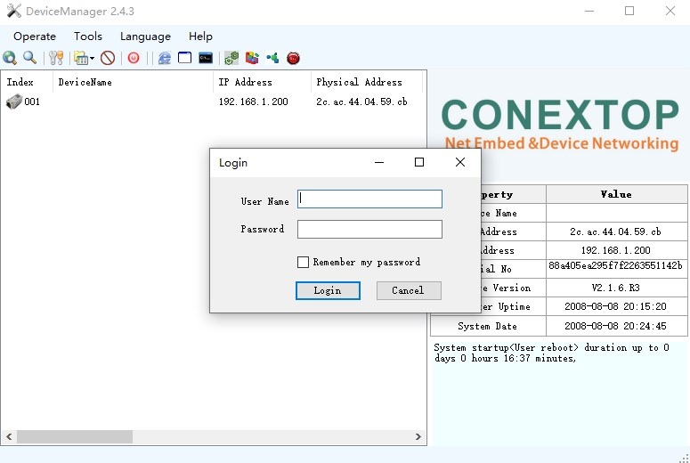

5.Modify IP: IP: 192.168.0.250 Gateway: 192.168.0.1 Then click OK；

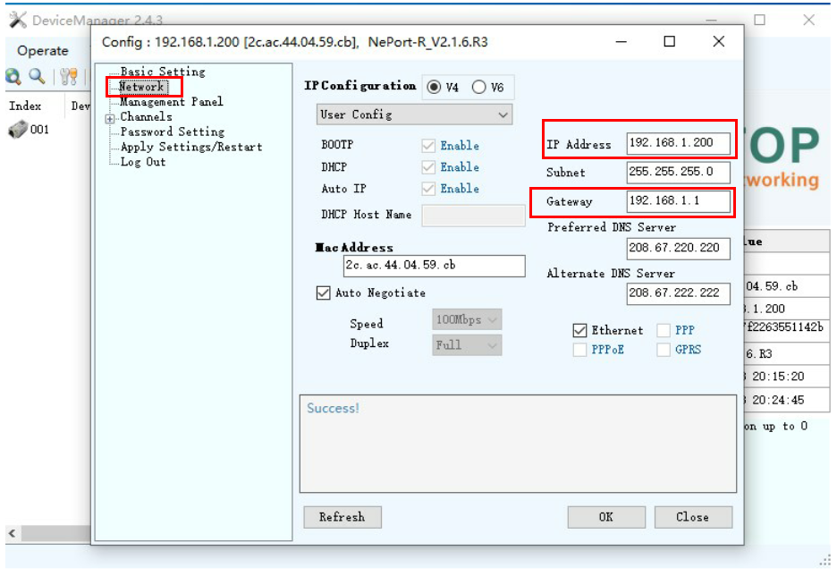

6.Modify the port number: Change the local port to 27011 and click OK；

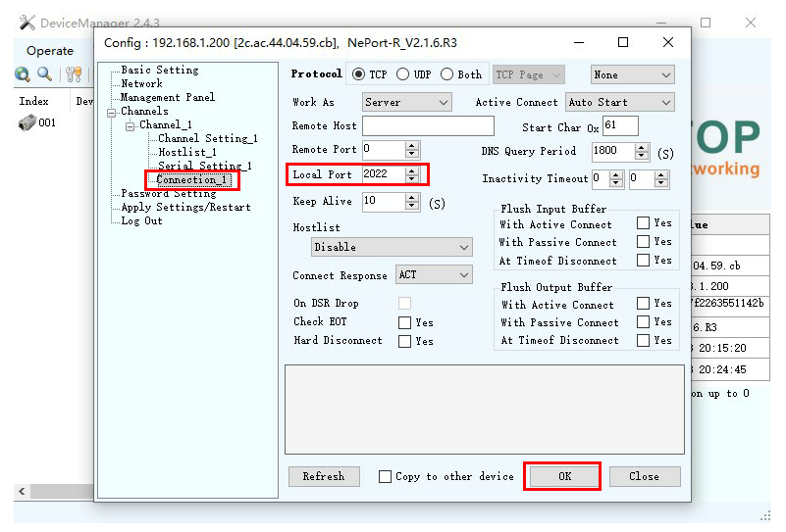

Note 1) The IP address modified in steps 5 and 6 needs to be in the same network segment as the computer IP address (e.g. if the computer IP address is 192.168.1.100, the device IP address needs to be modified to the format of 192.168.1.XXX)

Note 2) The IP address and port number modified in steps 5 and 6 are required when connecting to the device using the host computer software, as shown below

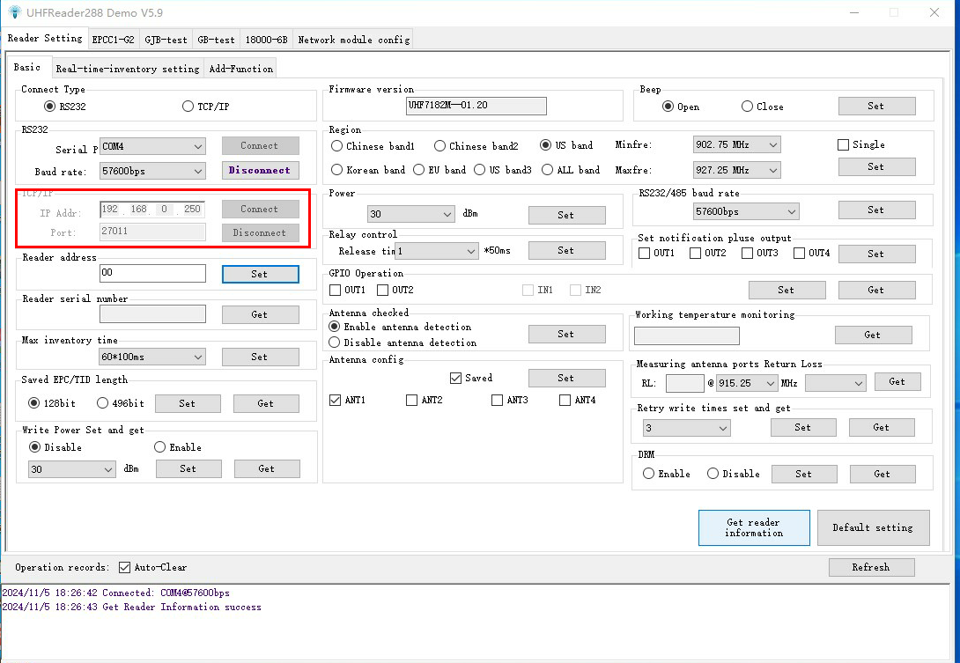

1. After modifying the IP address and port number, you need to save the parameters and restart to make them effective.

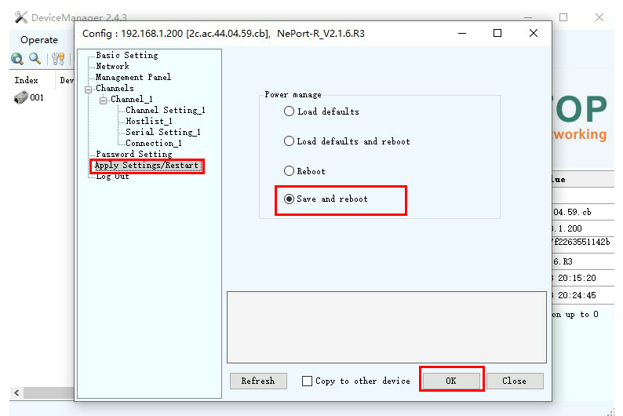

1. Check whether the IP modification is correct: Repeat the second step to search for the device and check whether the IP address of the searched device is the modified IP address. If not, follow the process again.；
2. **How to send data to a remote server？**

**As shown below: 1. Set the working mode to Both, the active connection method to Auto Start; fill in the server for the remote host and port.**

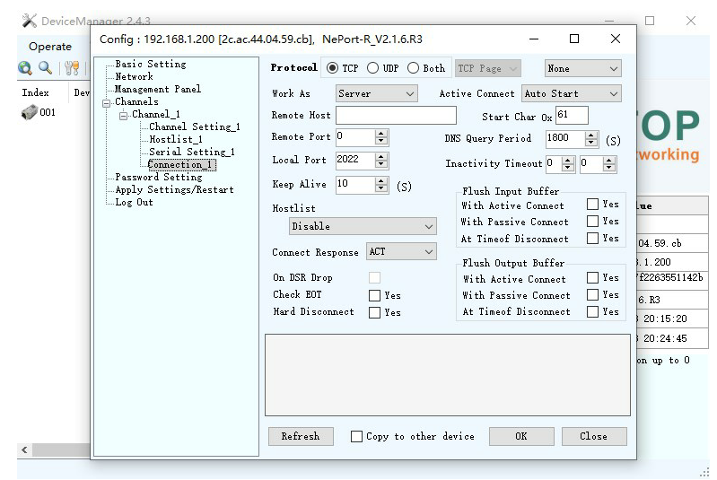

1. How to change the baud rate？

As shown in the figure below, after the modification is completed, you need to save the parameters and restart to take effect

